**COMMS PACK**

We encourage recipients of a Keith James Grant to promote their experience in a range of ways, from sharing learning with colleagues after completion to promoting attendance at an event via social media.

The support of Moondance Cancer Initiative should be acknowledged in any posters, abstracts, reports or published work that result from a Keith James Grant.

This comms packs gives you details on our social media accounts, suggested copy about the grants and downloadable links to logos and template powerpoint slides.

If you would like to request further graphics, logo versions or have a question relating to comms/branding for the Keith James Grants please email us at [**info@moondance-cancer.wales**](mailto:info@moondance-cancer.wales)

1. **SOCIAL MEDIA**

We encourage recipients to share their experience via social media platform and tag us.

X (Formerly Twitter)

You can find our X (Twitter) account here**:** <https://x.com/MoondanceCancer>.

Our handle is **@MoondanceCancer**

LinkedIn

You can find our LinkedIn account here: <https://www.linkedin.com/company/moondance-cancer-initiative/>

1. **LOGOS**

Please ensure the official Moondance Cancer Initiative Keith James Grants logo is used when creating posters, abstracts, reports or any work linked to the grant.

The logo is available in 4 transparent colour variations.

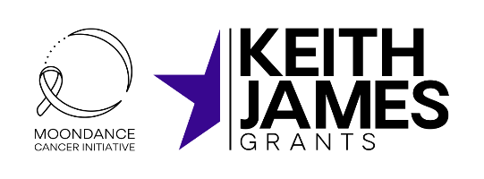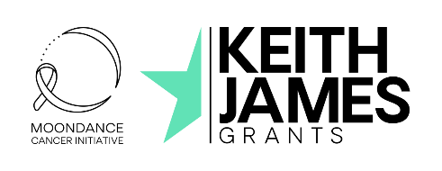

Keith James Grants – logo variations (examples)

**Download high-res versions of the above logos for use** [here.](https://moondance-cancer.wales/cms-assets/download/MCI-KJG-Logo-Variations-x-4.zip)

1. **TEMPLATE SLIDES**

**Download the template slides for use** [here.](https://moondance-cancer.wales/cms-assets/download/Keith-James-Grants-Stakeholder-Template-Slides.pptx)

1. SAMPLE COPY

About the **Keith** James Grants

Through the Keith James Grants, a total of **£1 million** is available to support NHS Wales professionals to access learning and development opportunities locally, nationally, and internationally.

Anyone working within the NHS in Wales, clinical, medical, or administrative, whose role has a direct connection to cancer services is eligible to apply.

Recipients of a Keith James Grant share Moondance Cancer Initiative’s motivation to improve cancer outcomes for patients across Wales. They are committed to putting their learning into action for the benefit of patients, their role, and their team.

About **Moondance Cancer Initiative**

Moondance Cancer Initiative is a not-for-profit company that aims to accelerate significant and sustained improvement in cancer survival outcomes over the next 10 to 15 years in Wales. Since 2020, they have helped find, fund and fuel brilliant people and brave ideas to improve cancer outcomes.

1. COLOURS

If you have any questions relating to comms/branding for the Keith James Grants please email us at [**info@moondance-cancer.wales**](mailto:info@moondance-cancer.wales)**,**