COMMS PACK

We encourage Keith James Grant recipients to share their experience in a variety of ways - from sharing learning with colleagues after completion to promoting attendance at an event via social media.
The support of Moondance Cancer Initiative should be acknowledged in any posters, abstracts, reports or published work that result from a Keith James Grant.
This pack gives you details on our social media accounts, suggested wording about the grants, links to downloadable logos and template powerpoint slides.
For additional graphics, logo variations, or any comms or branding queries, feel free to email us at: info@moondance-cancer.wales

- SOCIAL MEDIA
We encourage recipients to share their experience via social media platforms and tag us.
LinkedIn
You can find our LinkedIn account here: https://www.linkedin.com/company/moondance-cancer-initiative/

Bluesky
You can find our Bluesky account here: https://bsky.app/profile/moondancecancer.bsky.social
Our handle is @moondancecancer.bsky.social

.
- LOGOS
Please ensure the official Moondance Cancer Initiative Keith James Grants logo is used when creating posters, abstracts, reports or any work linked to the grant.
The logo is available in 4 transparent colour variations.
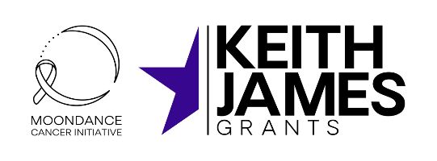
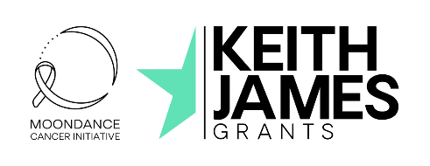


Keith James Grants – logo variations (examples)

Download high-resolution versions of the above logos for use here.

- TEMPLATE SLIDES
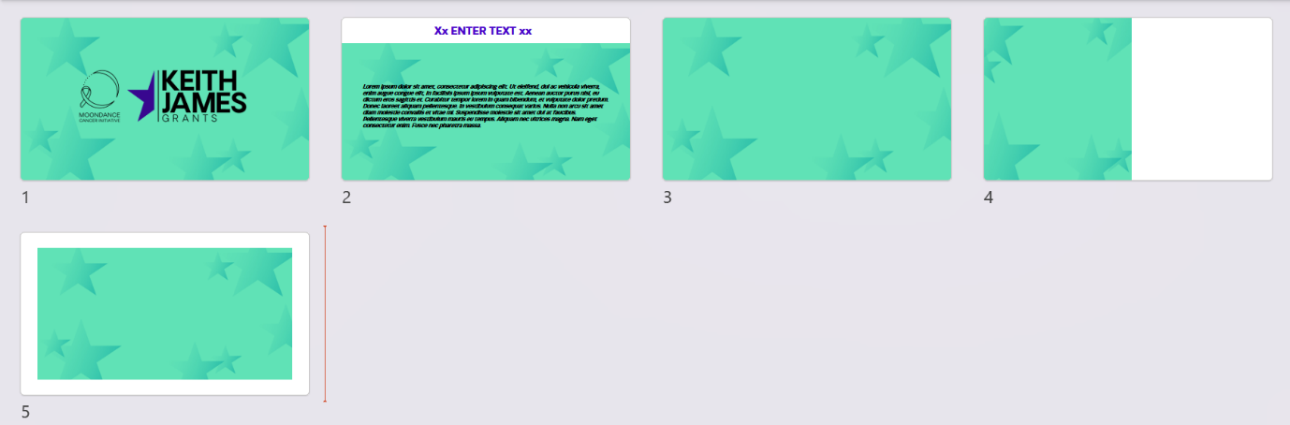

Download the template slides for use here.

- SAMPLE WORDING

About the Keith James Grants

Through the Keith James Grants, a total of £1 million is available to support NHS Wales professionals to access learning and development opportunities locally, nationally, and internationally.
Anyone working within the NHS in Wales, clinical, medical, or administrative, whose role has a direct connection to cancer services is eligible to apply.
Recipients of a Keith James Grant share Moondance Cancer Initiative’s motivation to improve cancer outcomes for patients across Wales. They are committed to putting their learning into action for the benefit of patients, their role, and their team.
About Moondance Cancer Initiative

Moondance Cancer Initiative is a not-for-profit company that aims to accelerate significant and sustained improvement in cancer survival outcomes over the next 10 to 15 years in Wales. Since 2020, they have helped find, fund and fuel brilliant people and brave ideas to improve cancer outcomes.

- COLOURS
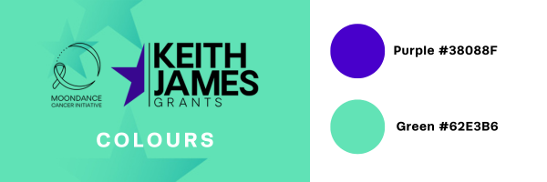

If you have any questions relating to comms/branding for the Keith James Grants please email us at info@moondance-cancer.wales,

